Authentication and Authorization

1. Require users to authenticate.

* sudo mongod –auth

1. Create an admin user.

* db.createUser({user: 'giovani', pwd: '1234', roles: ['userAdminAnyDatabase']})

1. Authenticate

* db.auth('giovani', '1234')

1. Roles:

* 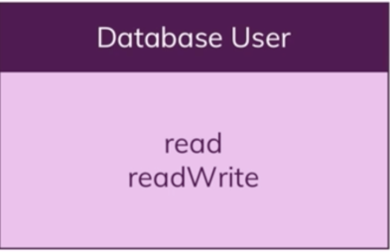
* 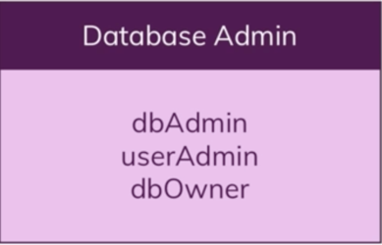
* 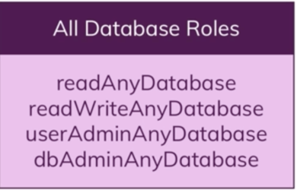
* 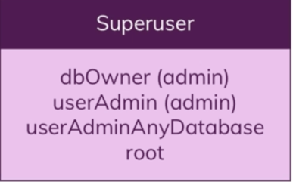
* 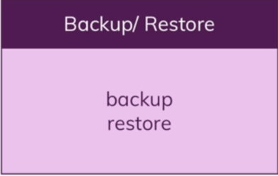
* 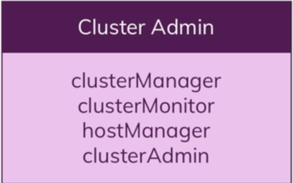

1. Update a user